The Doctor requests your presence

on board the

TARDIS

for a night’s journey

through time

and space to celebrate

FELICIA’S 12th Regeneration.

The coordinates

are set for

Street, Wyoming

on the planet of Gallifrey

Sat. Sept. 14, at 6pm

until

Sun Sept. 15 at 11am

“Always bring a banana to a party, bananas are cool.”

R.S.V.P. or be Exterminated.

519-

The Doctor requests your presence

on board the

TARDIS

for a night’s journey

through time

and space to celebrate

FELICIA’S 12th Regeneration.

The coordinates

are set for

Street, Wyoming

on the planet of Gallifrey

Sat. Sept. 14, at 6pm

until

Sun Sept. 15 at 11am

“Always bring a banana to a party, bananas are cool.”

R.S.V.P. or be Exterminated.

519-

The Doctor requests your presence

on board the

TARDIS

for a night’s journey

through time

and space to celebrate

FELICIA’S 12th Regeneration.

The coordinates

are set for

Street, Wyoming

on the planet of Gallifrey

Sat. Sept. 14, at 6pm

until

Sun Sept. 15 at 11am

“Always bring a banana to a party, bananas are cool.”

R.S.V.P. or be Exterminated.

519-

The Doctor requests your presence

on board the

TARDIS

for a night’s journey

through time

and space to celebrate

FELICIA’S 12th Regeneration.

The coordinates

are set for

Street, Wyoming

on the planet of Gallifrey

Sat. Sept. 14, at 6pm

until

Sun Sept. 15 at 11am

“Always bring a banana to a party, bananas are cool.”

R.S.V.P. or be Exterminated.

519-

The Doctor requests your presence

on board the

TARDIS

for a night’s journey

through time

and space to celebrate

FELICIA’S 12th Regeneration.

The coordinates

are set for

Street,

Wyoming

on the planet of Gallifrey

Sat. Sept. 14, at 6pm

until

Sun Sept. 15 at 11am

“Always bring a banana to a party, bananas are cool.”

R.S.V.P. or be Exterminated.

519-

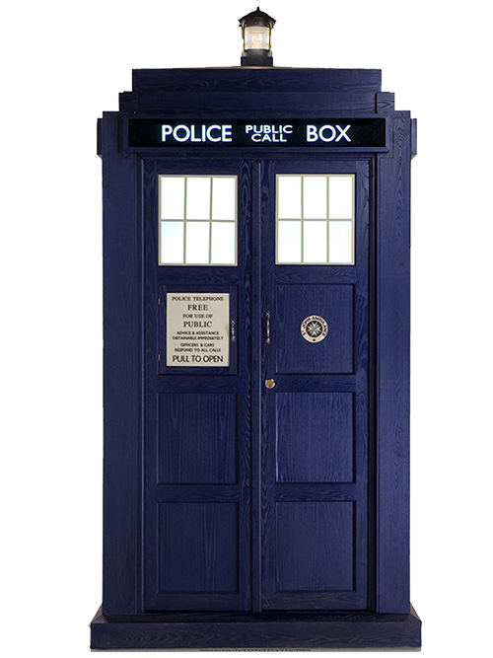

**3. Using an exacto knife, on shape ‘B’, cut along the top and bottom of the doors and along the middle. Fold along the edges of the doors so that they ‘open’.**

**4. Glue B onto the blue cardstock to make**

**the front of the card. Don’t glue**

**the doors!**

**5. Glue C and D onto the insides**

**of the doors.**

**6. Write your message inside and**

**you are done!**

1. **Cut out all of the designs below. 2. Glue ‘A’ onto blue cardstock and cut around the shape of the Tardis to create the back of the card.**

**C D**

**Tardis Card Instructions**

**B**

**A**