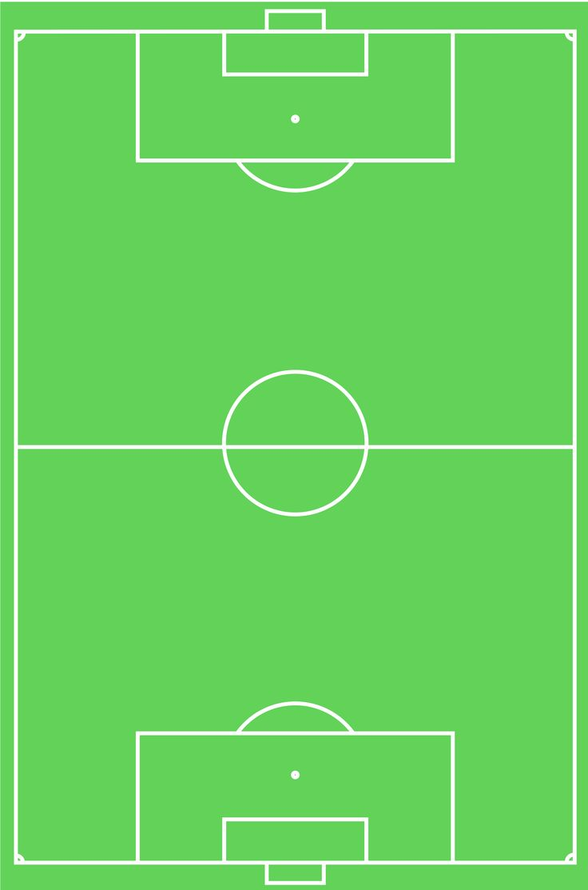

**Tristan’s**

**8th**

**Birthday!**



**Tristan’s**

**8th**

**Birthday!**



**Tristan’s**

**8th**

**Birthday!**



**Tristan’s**

**8th**

**Birthday!**